

ACME Staff Survey Results

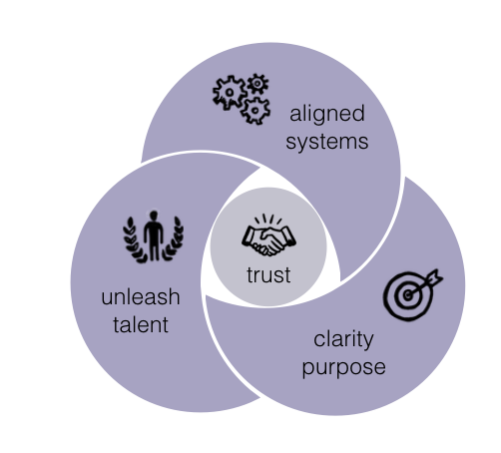
The Four Essentials of a Successful Organisation
The Impact of the Four Essentials
Low Trust | High Trust
Backbiting, infighting, victimism, defensiveness, not sharing information | Collaboration, mutual support, openness, sharing information
No Clear Purpose/Vision | Clear Purpose/Vision
Ambiguity, hidden agenda, political games, chaos | Clarity, togetherness, one team, alignment
Under-utilised Talent | Unleashed Talent
Apathy, moonlighting, daydreaming, boredom, anger, fear | Engagement, commitment, motivation, enjoyment
Bureaucratic Misaligned Systems | Aligned Systems
Silos interdepartmental rivalry, competing objectives | Efficiency, one team, productivity, mutual support

Results Summary

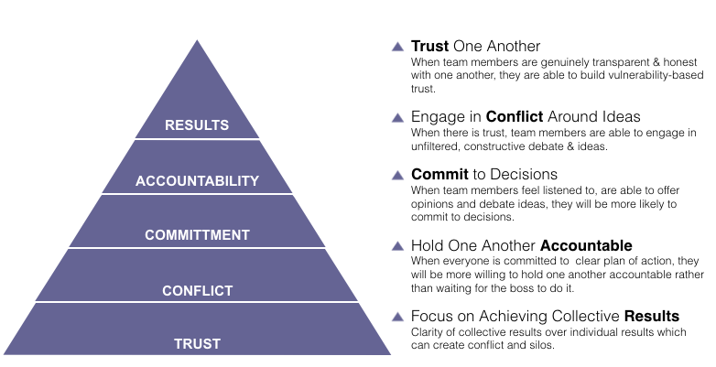
The 5 Critical Elements of Successful Teams

Results Summary

Overall Results

1. Our work culture is one where we openly invite feedback from each other about how we are performing.

 | Almost Never (1) | Rarely (2) | Sometimes (3) | Usually (4) | Almost Always (5) | Rating Average
 | 0 | 0 | 4 | 11 | 6 | 4.10

2. We are all very clear about our objectives and priorities.

 | Almost Never (1) | Rarely (2) | Sometimes (3) | Usually (4) | Almost Always (5) | Rating Average
 | 0 | 0 | 8 | 10 | 3 | 3.76

3. We leave meetings feeling secure that all members are dedicated to the decisions that were agreed upon.
 | Almost Never (1) | Rarely (2) | Sometimes (3) | Usually (4) | Almost Always (5) | Rating Average
 | 0 | 2 | 4 | 13 | 2 | 3.71

4. We value organisation success more than individual achievement.
 | Almost Never (1) | Rarely (2) | Sometimes (3) | Usually (4) | Almost Always (5) | Rating Average
 | 0 | 2 | 5 | 10 | 4 | 3.76

5. When we fail to reach our organisation goals, each of us feels a personal responsibility to improve the performance of our group.

 | Almost Never (1) | Rarely (2) | Sometimes (3) | Usually (4) | Almost Always (5) | Rating Average
 | 0 | 1 | 5 | 11 | 4 | 3.86

6. We have clear and open discussions with our leader(s) about what is expected.

 | Almost Never (1) | Rarely (2) | Sometimes (3) | Usually (4) | Almost Always (5) | Rating Average
 | 0 | 2 | 2 | 11 | 6 | 4.00

7. We are all involved is setting the vision and direction of our organisation.

 | Almost Never (1) | Rarely (2) | Sometimes (3) | Usually (4) | Almost Always (5) | Rating Average
 | 0 | 1 | 8 | 12 | 0 | 3.52

8. We are directly focused on meeting the needs and desires of our end users and/or customers.

 | Almost Never (1) | Rarely (2) | Sometimes (3) | Usually (4) | Almost Always (5) | Rating Average
 | 0 | 2 | 7 | 10 | 2 | 3.57

9. Our team members each understand how they impact the organisations financial success.

 | Almost Never (1) | Rarely (2) | Sometimes (3) | Usually (4) | Almost Always (5) | Rating Average
 | 0 | 2 | 6 | 9 | 4 | 3.71

10. We have clear measures that track our progress on the key performance indicators.

 | Almost Never (1) | Rarely (2) | Sometimes (3) | Usually (4) | Almost Always (5) | Rating Average
 | 1 | 2 | 8 | 8 | 2 | 3.38

11. People are recognised and rewarded for performance.

 | Almost Never (1) | Rarely (2) | Sometimes (3) | Usually (4) | Almost Always (5) | Rating Average
 | 0 | 8 | 9 | 3 | 1 | 2.86

12. The right people are in the right job.

 | Almost Never (1) | Rarely (2) | Sometimes (3) | Usually (4) | Almost Always (5) | Rating Average
 | 0 | 0 | 5 | 13 | 3 | 3.90

13. We routinely use feed back from our customers/end user to improve our performance.

 | Almost Never (1) | Rarely (2) | Sometimes (3) | Usually (4) | Almost Always (5) | Rating Average
 | 0 | 2 | 11 | 8 | 0 | 3.29

14. We create new systems and processes that help us to do our work better.

 | Almost Never (1) | Rarely (2) | Sometimes (3) | Usually (4) | Almost Always (5) | Rating Average
 | 0 | 0 | 6 | 13 | 2 | 3.81

15. People are paid fairly for the work they do.

 | Almost Never (1) | Rarely (2) | Sometimes (3) | Usually (4) | Almost Always (5) | Rating Average
 | 0 | 3 | 11 | 7 | 0 | 3.19

16. Do I know what is expected of me at work?

 | Almost Never (1) | Rarely (2) | Sometimes (3) | Usually (4) | Almost Always (5) | Rating Average
 | 0 | 0 | 1 | 13 | 7 | 4.29

17. Do I have the materials and equipment I need to do my work right?

 | Almost Never (1) | Rarely (2) | Sometimes (3) | Usually (4) | Almost Always (5) | Rating Average
 | 0 | 0 | 4 | 13 | 4 | 4.00

18. At work, do I have the opportunity to do what I do best everyday?

 | Almost Never (1) | Rarely (2) | Sometimes (3) | Usually (4) | Almost Always (5) | Rating Average
 | 0 | 2 | 9 | 7 | 3 | 3.52

19. Does my supervisor, or someone at work, seem to care about me as a person?

 | Almost Never (1) | Rarely (2) | Sometimes (3) | Usually (4) | Almost Always (5) | Rating Average
 | 2 | 1 | 1 | 5 | 12 | 4.14

20. Is there someone at work who encourages my development?

 | Almost Never (1) | Rarely (2) | Sometimes (3) | Usually (4) | Almost Always (5) | Rating Average
 | 2 | 3 | 3 | 7 | 6 | 3.57

21. At work, do my opinions seem to count?

 | Almost Never (1) | Rarely (2) | Sometimes (3) | Usually (4) | Almost Always (5) | Rating Average
 | 0 | 0 | 8 | 10 | 3 | 3.76

22. Does the mission/purpose of my company make me feel like my work is important?

 | Almost Never (1) | Rarely (2) | Sometimes (3) | Usually (4) | Almost Always (5) | Rating Average
 | 0 | 1 | 0 | 9 | 11 | 4.43

23. Are my co-workers committed to doing quality work?

 | Almost Never (1) | Rarely (2) | Sometimes (3) | Usually (4) | Almost Always (5) | Rating Average
 | 0 | 0 | 2 | 9 | 10 | 4.38

24. In the last six months, have I talked with someone about my progress?

 | Almost Never (1) | Rarely (2) | Sometimes (3) | Usually (4) | Almost Always (5) | Rating Average
 | 3 | 2 | 6 | 4 | 6 | 3.38

25. At work, have I had opportunities to learn and grow?

 | Almost Never (1) | Rarely (2) | Sometimes (3) | Usually (4) | Almost Always (5) | Rating Average
 | 1 | 1 | 3 | 10 | 6 | 3.90

26. We have clear measures established to progress on our goal.

 | Almost Never (1) | Rarely (2) | Sometimes (3) | Usually (4) | Almost Always (5) | Rating Average
 | 0 | 0 | 6 | 13 | 2 | 3.81

27. We have an environment that enables people to achieve their highest potential.

 | Almost Never (1) | Rarely (2) | Sometimes (3) | Usually (4) | Almost Always (5) | Rating Average
 | 0 | 3 | 7 | 11 | 0 | 3.38

28. It is easy to talk it over with our leaders if something goes wrong?

 | Almost Never (1) | Rarely (2) | Sometimes (3) | Usually (4) | Almost Always (5) | Rating Average
 | 0 | 2 | 6 | 7 | 6 | 3.81

29. We receive positive and developmental feedback.

 | Almost Never (1) | Rarely (2) | Sometimes (3) | Usually (4) | Almost Always (5) | Rating Average
 | 1 | 2 | 8 | 8 | 2 | 3.38

30. I am given opportunities for ongoing learning and development needed to do my job well.

 | Almost Never (1) | Rarely (2) | Sometimes (3) | Usually (4) | Almost Always (5) | Rating Average
 | 1 | 6 | 9 | 3 | 2 | 2.95

32. Our Leader(s) are seen as a source of help and support.

 | Almost Never (1) | Rarely (2) | Sometimes (3) | Usually (4) | Almost Always (5) | Rating Average
 | 1 | 6 | 9 | 2 | 3 | 3.00

33. We often challenge existing practices with creative alternatives.

 | Almost Never (1) | Rarely (2) | Sometimes (3) | Usually (4) | Almost Always (5) | Rating Average
 | 1 | 0 | 5 | 11 | 4 | 3.81

